Version 1.1

Revision History

|  |  |  |  |
| --- | --- | --- | --- |
| Date | Version | Description | Author |
| 17/Oct/2013 | 1.0 | Initial UC description | Storm Cloud Development |
| 22/Oct/2013 | 1.1 | Updated diagrams  Inserted Cucumber code  Added Mockups | Storm Cloud Development |
|  |  |  |  |
|  |  |  |  |

Table of Contents

1. Use-Case manage rights 4

1.1 Brief Description 4

1.2 Stored data 4

1.2.1 Overview 4

1.2.2 Description 4

2. Flow of Events 5

2.1 Screen Flow 5

2.2 Use Case Flows 5

2.2.1 Show all bookings (List View) 5

2.2.2 Show single booking (View Single) 6

2.2.3 Edit booking (Edit) 7

3. Special Requirements 8

4. Preconditions 8

4.1 Rights 8

5. Postconditions 8

6. Extension Points 8

# Use-Case manage rights

## Brief Description

The use case describes how a admin can change and view settings specified for each user. So it is possible to adjust specific quotas or give users special rights. Also an administrator can block users from using the calendar app or the mail app.

## Stored data

### Overview

|  |  |  |  |  |
| --- | --- | --- | --- | --- |
| Name | Auto-assigned | Unique | Mandatory | Modifiable |
| User | Yes | Yes | Yes | No |
| Can Use Mail Client | No | No | Yes | Yes |
| Can Use Calendar | No | No | Yes | Yes |
| Maximum Inbox Size | No | No | No | Yes |
| Maximum Mail Account Number | No | No | No | Yes |
| Maximum Calendar Number | No | No | No | Yes |
| Mail Client Admin | No | No | No | Yes |
| Calendar Admin | No | No | No | Yes |
| General Admin | No | No | No | Yes |

### Description

Settings are specific for each user. A administrator can change the mail client settings. So he can limit the inbox size and the mail account number. As mail administrator he can forbid the usage of the mail client. A calendar administrator can limit the number of calendars and he also can forbid the usage of the calendar app. A general administrator can provide other users administrator rights. If a new user registers he is able to use both, mail client and calendar, but he has no limitations.

# Flow of Events

## Screen Flow

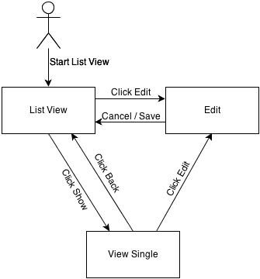

## Use Case Flows

### Show all users (List View)

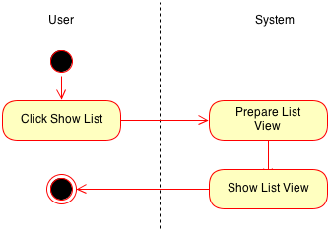

### Show user rights (View Single)

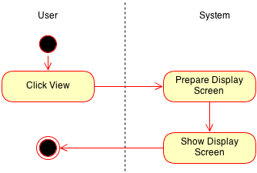

### Edit rights (Edit)

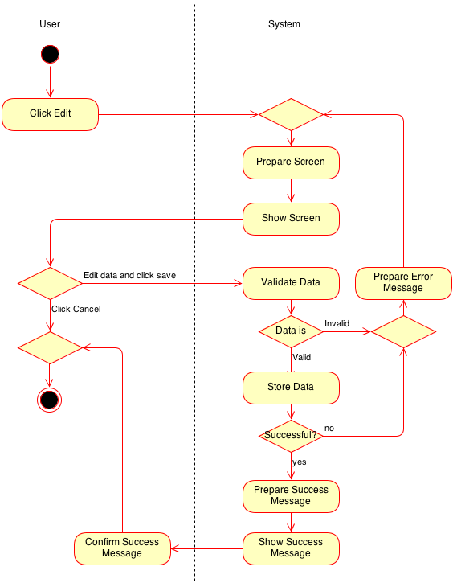

# Special Requirements

n/a

# Preconditions

## Rights

View/edit: The user must have the rights to do the operation.

# Postconditions

n/a

# Extension Points

n/a

# Cucumber test scenario / narration

Feature: manage rights

As an general administrator

I want to administrate different rights for the user

So that I can set quotas and other regulations

Scenario: set size of inbox for user

Given I am logged in

And I am on the "user list"

And I clicked "manage rights"

When I type in the new inbox size

And I click "save"

Then I should see a confirmation message

Scenario: set maximum number of mail accounts

Given I am logged in

And I am on the "user list"

And I clicked "manage rights"

When I type in the new maximum mail account number

And I click "save"

Then I should see a confirmation message

# Mockups

## Show all users

## Show user rights

## Edit rights